**Exercises Day 2 Image analysis with ImageJ / Fiji**

**Exercise 1) Rolling ball background correction**

Open Sample Image >Cell Colony

Draw a line diagonally from top left to bottom right across image

Use Histogram (H) & use Analyze / Plot Profile (K) (use both in Live mode)

Fix the Y axis range to 0-255 (Plot of cell colony / More…)

Process / Subtract background… (use Preview)

(50, 10, 2 pixels, with and without disable smoothing)

**Exercise 2) Image Calculator plus (removes a known uneven background from other images)**

Open the images in the background folder.

Process / Calculator Plus:

i1 = Image i2 = background

Use divide, and add the mean intensity of the background image as k1.

**Exercise 3) Measure western blots**

Open a western blot image, and chose a protein lane

Use segmented line tool. Draw dot-to-dot style across the bands.

Set the line width to cover the bands.

Plot profile.

Move the line up or down and plot profile of background.

Remove gridlines. (More>> axis options / Draw Grid)

Adjust range. (More>> Set Range… 0-255)

Use Process / Image Calculator and combine the 2 graphs with ‘min’

Draw 1 pixel straight lines between each lane. (use draw of Fill to draw the lines – check colours has foreground as black, if not use ‘delete’)

Use magic wand to highlight each band. Press T (ROI manager). Set measurements to area.

Select all ROIs and measure.

**Exercise 4) Manual Cell Counter**

Open Blobs.gif

Open cell counter (Plugins / Analyze / Cell counter)

Initialize

Remove some types

Hit type 1, click on the image…

Options: Change colours of each type (do yellow)

Delete mode to remove mistakes.

Hit type 2, clickety clickety click…

Results…

Measure…

**Exercise 5) Automatic counting Thresholding**

Open Blobs.gif

Threshold

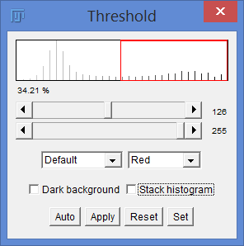 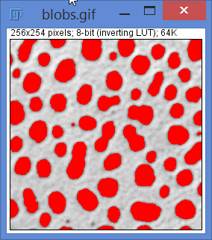 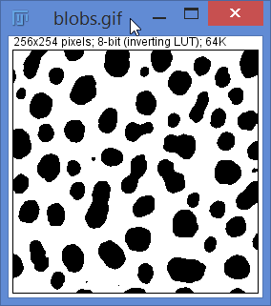

Analyze particles

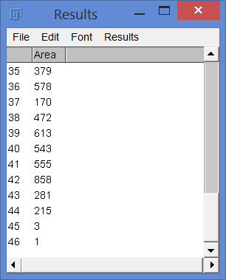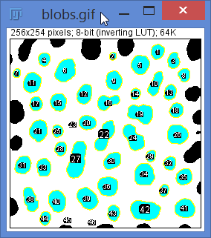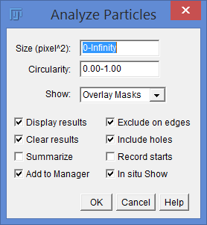

Some are clearly overlapping, should be counted twice.

Some are too small…

After the threholding: Process / Binary / Watershed…

Set a minimum particle size.

Show: Masks

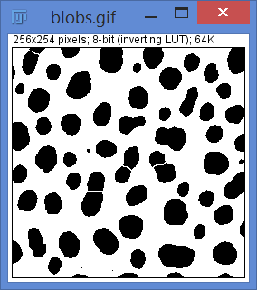 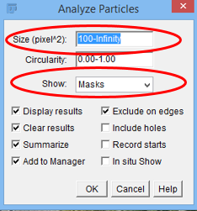 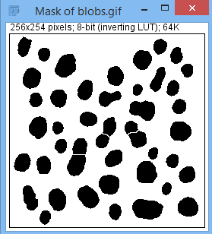

Use the ROI manager to show the ROIs on the original image.

**Exercise 6) Counting real samples (thresholding, local threshold, find maxima)**

Open image Cell Counting 1. Duplicate it (good practice, so you aren’t working on the original file).

Change it to 8 bit (Image / Type… 8 bit), Press ‘Shift + T’ (Threshold).

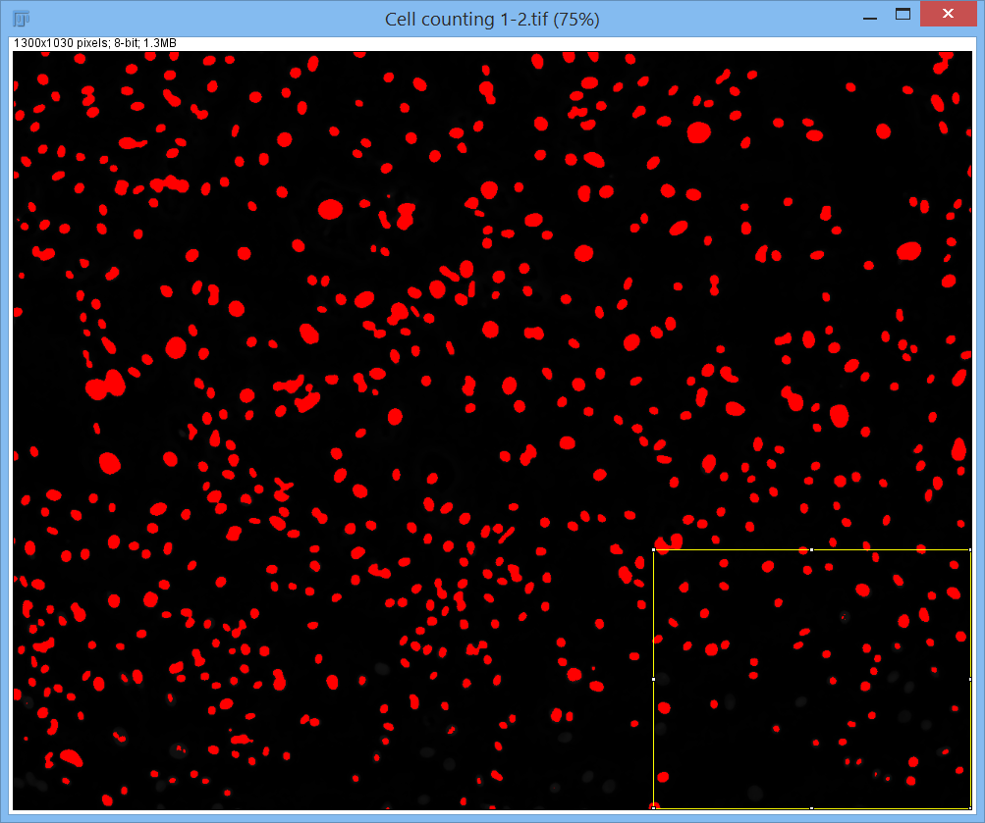 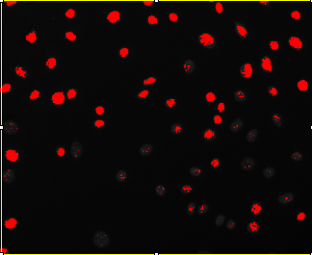

The image isn’t evenly bright, so bottom right corner cells are missed.

Subtract background (rolling ball radius 20), then median filter (4 pixels – to remove the bright spots in the nuclei):

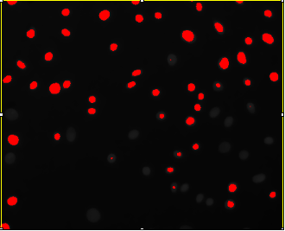 Fixed the spots but still missing some.

Try all the different threshold algorithms…

Image / Adjust / Autothreshold… try all… looks like #15 wins (triangle).

Watershed to split overlaps:

 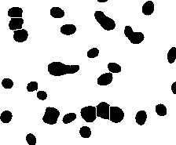

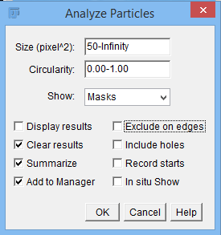 Analyze particles (choose to exclude edges or not)

Further improvement with AutoLocal Threshold…

Image / Adjust / AutoLocal Threshold… Try all (radius 20)…

Phansalkar wins.

Repeat the Watershed and Analyse Particles step.

Apply the new ROI manager to the original image to check the counts:

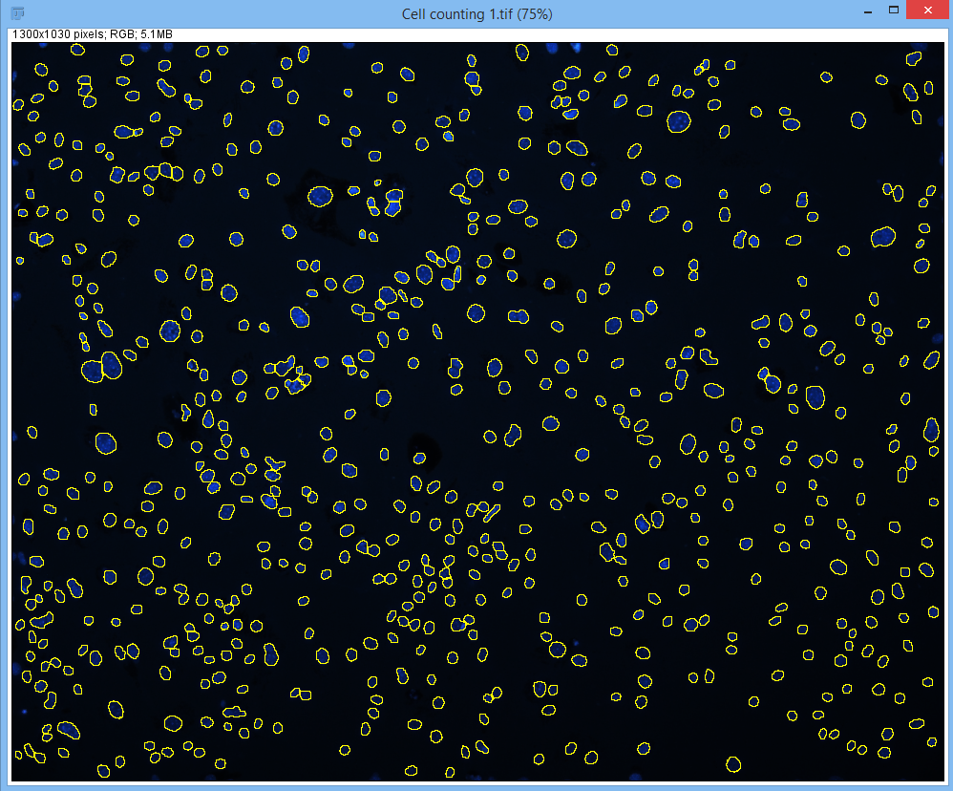

**Counting with Find Maxima…**

On a duplicate of the original image, subtract background (20), Gaussian Filter (3) (WHY??).

Process / Find Maxima… (try different values using preview)

**Exercise 7) Count cilia and measure lengths**

Cilia. Need to know how many and how long they are.

Find maxima no good (only counts them).

Therefore, segment to a binary image then measure the lengths.

How??

Image: Exercise images/ Cilia lengths. Choose one image.

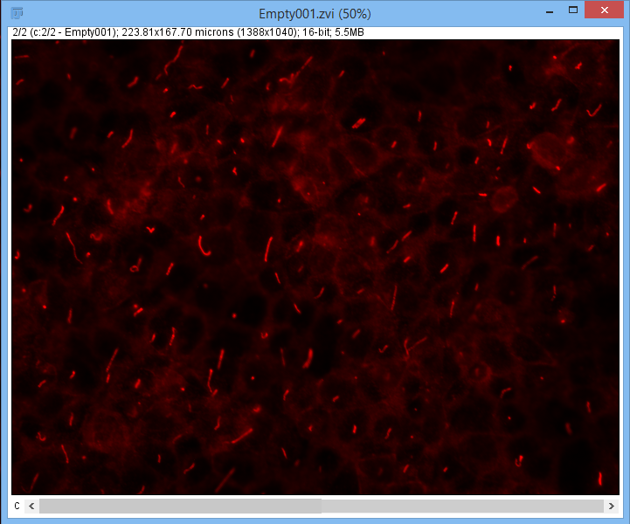 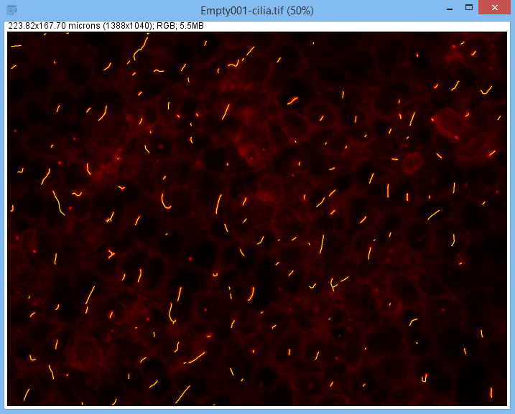

Hints: Background correction.

Filter (keeping edges).

Threshold to get a binary (black and white) image.

Binary Dilate to join up cilia pieces that may have split in two.

Binary – Skelotonize, makes the cilia 1 pixel wide.

Measure the skeletons. Length isn’t an option, so perimeter divided by 2 will be the length.

Add results to ROI manager. Use the ROI manager to overlay the identified cilia on the original image.

Once you’ve done this try the macro: Cilia2Dlengths.ijm (drag to ImageJ, press RUN).

**Exercise 8) Identifying double stained cells**

Often you need to measure cells that are positive for a particular stain.

A nuclear or cytoplasmic marker.

Use thresholding to make a binary image of each channel, then use ‘Image Calculator’ to add or subtract images from each other to identify overlaps.

File: Exercise Images / Double Stained cells/ Dapi_GreenCytoplasm_RedNuclei.lsm

Procedure:

Image / Color / Split channels

Dapi: Median(3). Threshold Triangle. Watershed. Analyze particles (20-Infinity) Show Masks.

Green: Median(2). Threshold Default. Analyze paricles (50) Masks.

Red: As for Dapi.

Image Calculator:

Mask C2 AND C3

Combine orig 3 colours + new binary image.

How to make the output overlaps the size of the nuclei: Use the magicwand macro.

Take the overlaps image. Find maxima with the output as a list.

Run the macro, with the Red thresholded image active.

Easier still, there’s a plugin for that:

Manage update sites; IJPB-plugins.

Plugins/ morpholibJ / Morphological reconstruction:

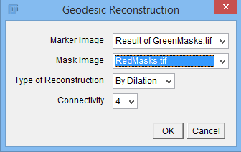

Marker Image – starting points

Mask Image – the image that the markers grow into

**Exercise 9) Write a macro to count the nuclei in a single image in the Drosophila Cells folder**

Use the macro recorder.

Try with find maxima or thresholding.

Add results to ROI manager so you can look at them on the original image.

**Exercise 10) Write a macro to count all the dapi images in Drosophila Cells folder**

Goals:

Auto count the nuclei in more than one file.

Save the results (save the summary window at the end).

Save an image of each counted file so you can check how accurate the counts are.

Hints:

Add code to only open files with dapi.tif in the title.

Adapt macros from the macros folder (Start with: EmptyFolderProcessingMacro.ijm).

See Cilia2D macro for how to save pictures as you run the macro, and how to save the summary. Do the macro first without saving any pictures, then try with saving these too.

If using FindMaxima, you can output as Single points, then dilate the resulting image and use analyse particles to add the counts to a summary window.

To make an output image, merge the channels of the input image and the find maxima output image. Save as a tif or Jpeg. (or both – see the differences).

You will need to change the merge channels line from the Record macros version. It needs to have the names of the images you are working on. Use the string +Imagename+

i.e. “c1=[“+Imagename+”.TIF Maxima]

You can also add the results of Analyze particles to the ROI manager. (Clear results, Add to manager) and save the ROImanager results, (see Cilia macro).